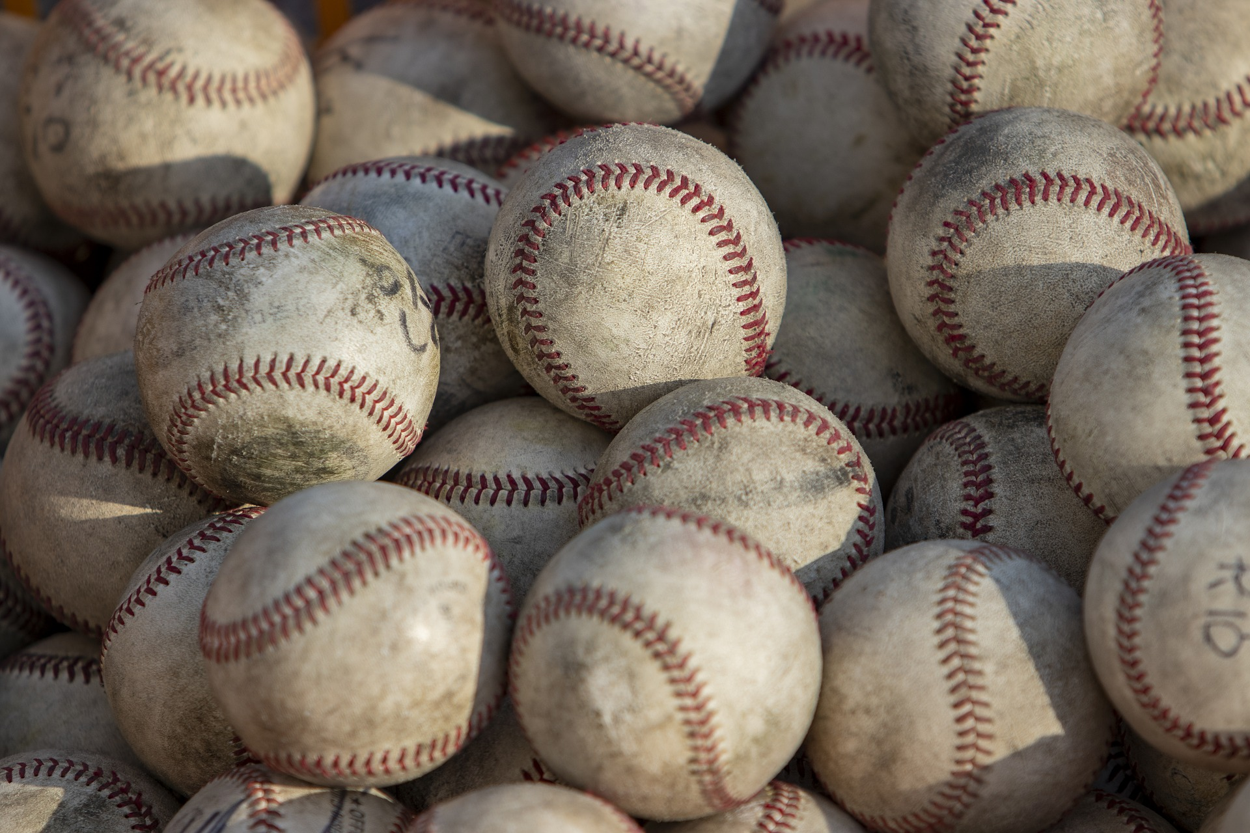
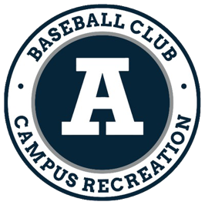
USU Baseball Club
baseballclub@aggies.usu.edu

2025 - 2026

Utah State University

Baseball Club
Content
What is the USU Baseball Club? 2
Eligibility Requirements 2
Tryouts 4
Fall Season 6
Off Season (Winter) 6
Spring Season 7
Additional Questions? 9

What is the USU Baseball Club?
The USU Baseball Club is a member of the Campus Recreation Department at Utah State University. The mission of the team is to provide opportunities for students interested in baseball to improve their skills and participate in a highly competitive league.
The Baseball Club is not an intramural team, it is a highly competitive team that competes with some of the top baseball programs in the region (e.g. Salt Lake Community College, College of Southern Idaho, USU Eastern). Utah State is a member of the National Club Baseball Association (NCBA) which consists of 306 teams from around the United States.

National Championships
2012 | 2014

Region Championships
2012 | 2014 | 2017 | 2022 | 2023

Conference Championships
2011 | 2012 | 2014 | 2015 | 2016 | 2017 | 2018 | 2019 | 2021 | 2022 | 2023 | 2024

Eligibility Requirements
Although both the NCBA and Utah State University have their own eligibility requirement we have seen the University resort to what the NCBA rules are. But beware that this may not always be the case. Make sure that you are eligible for both the NCBA and USU.

NCBA
As each player is different it is tough to sum up all of what the NCBA has in its eligibility sections. Some of the main points are as follows:
- At the time of any roster submission, a letter from the academic institution must be submitted to the NCBA listing that each player holds a minimum 2.0 cumulative GPA and is not on academic warning or probation. (8.01.0)
  - Academic Warning (USU Definition)
  - Academic Probation (USU Definition)
- A player with any previous professional experience in the sport of baseball is NOT eligible to play in any NCBA Sanctioned Baseball Game. (7.04.0)
- A player playing in an NCBA Sanctioned Baseball Game MUST hold Full-Time Status with that team’s College or University. (7.07.0)
  - An exception is if a Final Semester Student requires less than a Full-Time load in order to graduate. (7.07.1)
  - An exception is if a player who graduates at the end of the fall semester will remain eligible to compete in the immediately following spring season provided, he is enrolled in at least 1 credit during the spring semester. (7.07.2)
  - An exception is if a player who begins the spring season as a registered student and then graduates in the middle of the season will remain eligible to compete for the remainder of the season. (7.07.3)
- Any player playing in an NCBA Sanctioned Baseball Game MUST have enrolled with Full-Time Status before their 25th Birthday. (7.08.0)
- Each student-athlete shall complete his five seasons of participation in intercollegiate baseball within six calendar years from the beginning of the semester or quarter in which the student-athlete first registered for a minimum full-time program of studies in a collegiate institution, with time spent in the armed services, on official church missions or with recognized foreign aid services of the U.S government being excepted. (7.09.0)
- For a player to participate in the NCBA using a fifth year of eligibility, that player must NOT have exhausted four years of eligibility at the Varsity Level. (7.10.0)
You can read the entire NCBA Rulebook here. Eligibility is covered in sections 7 & 8.

Utah State University
- All USU students participating in Club Sports must be registered for a minimum of 12 academic credits and maintain a cumulative 2.5 GPA or higher.
- Graduate students are to be registered for at least six credits and a 3.0 GPA.
- Ineligible players are not allowed to travel or participate in any practices, games, or competitions.
  - They may serve as advisors and/or coaches, but not as a competing member.
- Make sure you check with your national governing body pertaining to eligibility requirements. In some cases, students may be required to carry more credits and/or maintain higher GPA standards to be in compliance with national governing body guidelines.
You can read the entire Club Sports Manual here. Eligibility is covered on page 9.

Tryouts
The team is chosen based on the skill that players demonstrate during tryouts. We expect a high turnout this year, as we have averaged 50 players each of the past five seasons.

When / Where / Cost
Dates: Second week of September (Fall Tryouts) | Second week of January (Spring Tryouts)
Time: 3:00 pm – 5:30 pm
Where: Zollinger Park
Cost: $35
***Please refer to the website usubaseball.com, or social medias @usubaseball for the most up-to-date details.

Format
Each day will consist of pitching to ensure that position players have the opportunity to showcase their pitching skills.
Day 1 | Day 2 | Day 3
Fielding | Hitting / Running | BP Scrimmage*
*We’ve found that one of the key ways to evaluate players is by watching how they react to game situations. One way that we have found to get the most out of our limited time is to have players taking BP and having them take their last rep live with fielders reacting at game speed. This gives us the opportunity to simultaneously evaluate hitting and fielding.

Evaluations
Evaluations for players will be done by coaches, and team leadership. It is the hope of the coaching staff that each player trying out will receive an equal amount of reps, and an equal amount of opportunities to showcase their skills. We strive to create a fair atmosphere where new and returning players are given the same chance of making the team.
Because of the success of the program, we strive to be one of the top teams in the country year in, and year out. For this reason, we choose players that we feel can make either an immediate impact or ones that we feel will be vital to the success of the team in years to come.

Selection / Results
After the three days of tryouts the coaching staff, and team leadership, will meet to discuss which players will be taken for the Fall team.
The Fall team will consist of the best 25-30 players.
The final roster will be posted at usubaseball.com by 10 pm the Friday following.

Division II
The NCBA has three levels of competition to accommodate schools of varying sizes. Due to our high tryout numbers, we have the potential to field two teams each year to provide playing time for players further down the depth chart. The Division II team is dependent on tryout turnout, and player interest from year to year.

Fall Season
Date Range: September 10th – October 31st
Team Dues (Cost): $150 (subject to change)
Practices: Tuesday and Thursday’s from 3:00 pm – 5:00 pm
The fall season is treated as an extended tryout period. We will have between 8-10 games scheduled vs other opponents, including a home tournament. We will be scrimmaging during scheduled practice time and arranging for scrimmages on the weekends when we don’t have other opponents scheduled.
As a player funded team, we try to keep costs low during the fall season to save for the traveling and other expenses that we incur during the spring season. Fall dues cover uniform fees including hats and jerseys and basic operational costs such including game officials and field reservations.

Off Season (Winter)
Date Range: November 1st – January 10th
The offseason is used as a time to prepare for the spring season. Although we are giving this time to help players focus on schoolwork, we expect each of them to be improving their skills on their own time. We will be having several team meetings throughout this period to get the necessary paperwork, forms, and letters filled out. These necessary things are for helping the Club function smoothly, as well as for the purpose of the University, and the NCBA to ensure that all players are academically eligible.
The offseason will also include required team events that will help the team raise funding for the spring season. Some examples of these opportunities include cleaning the Spectrum after Basketball Games, providing security for the Hockey Club, cleaning the side of the highway, etc. Players are responsible for the funding of the team, and as such, it is expected that players will help out with team-sponsored fundraising events.
When winter break starts there will be no team events scheduled.

Spring Season
Date Range: January 10th – May 31st
Team Dues (Cost): $1000 (subject to change)
For the Spring season the team dues are more expensive due to out of state travel, hotel stays, officiating, equipment, and apparel. We want each player to have an incredible experience, and unfortunately being a self-funded team means that we must charge each player fees for the program to function.
Players are recommended to seek out sponsorships to cover spring dues. Dues are pushed to the spring to provide ample time for players to raise money.

Overview
The spring season is the main season. We have around 30 games scheduled for the spring season, which is similar to the length of the high school baseball season. Here are some of the places that we have traveled to in the past: Nevada, Arizona, Idaho, Montana, Colorado, Georgia, Florida, and North Carolina. We play other club teams, as well as some Community College teams which have included: USU Eastern, College of Southern Idaho, Salt Lake CC, Mesa CC, Glendale CC, and Paradise Valley CC to name a few from the past couple of years.

Practices (Indoor)
Tuesdays and Thursdays from either 8:00 pm – 9:30 pm or from 9:30 pm – 11:00
(Whichever time slot the university assigns us to. We should know by November which time slot that will be.)
Practices (Outdoor)
Tuesday’s and Thursday’s from 5:00 pm – 7:00 pm. These practices typically begin right after Spring break. However, there have been times when we were able to have a couple of practices outside during mid-February, but that isn’t common.

Spring Break
We try to have a full spring break with up to 8 games being played. This is a great opportunity for us to get out of the winter weather and travel to Nevada, Arizona, Colorado, Southern Utah, etc. Spring Break is typically the beginning of our season, we will then play games every weekend after that until the beginning of May where, if we qualify, we will have the opportunity for the post-season.

Typical Week
A typical week will be practices on Tuesday’s and Thursday’s, and then games on either Friday-Saturday, or Saturday-Sunday. For the conference series we play a doubleheader with two 7-inning games one day, and a single 9-inning game the other day. For series against Community Colleges, we typically play two days of double-headers, one 7 innings, and one 9 inning game each day.

Sunday Play
Although we try to avoid playing on Sundays it is inevitable that we will have to play a couple of games on Sundays. Being a school in Utah, we understand that some players decide to not play on Sundays. If you are one of these players, please don’t worry, we will make accommodations and understand the decision. There will be no repercussions to missing a Sunday game, except for the fact that you won’t be getting the reps and allowing somebody else the opportunity to possibly get ahead of you on the depth chart because of the skills that they displayed while you weren’t playing.

Post-Season
The dates for the Post-Season are:
Regional Tournament: May 12th – 14th, Location: Nampa, ID
NCBA World Series: May 26th – June 1st, Location: Alton, IL
These dates are something to be aware of when planning items for the summer.

Additional Questions?
If you have any additional questions that weren’t covered, please don’t hesitate to reach out to one of the members of the coaching staff, or team leadership.
We look forward to seeing you at tryouts this season and seeing if you have what it takes to be a part of the USU Aggies Baseball Club.

Contact
President: Vincent Rohrer | vincent.rohrer@gmail.com
Club Sports Coordinator: Josh Ryan | joshua.ryan@usu.edu

More information
Team Website
Club Sports Resources
NCBA Documents
Instagram

