Table of Contents
Login
Coursedog Home Screen Overview Terms
Adding a Course from Inventory Requests
Rooms Adding a Section
Editing an Existing Section Section Configuration
Cancelling a Section
Section with Multiple Instructors
Section with Multiple Meeting Patterns
Adding a New Section if the Term is Locked
Adding a New Section from Course Inventory

Login
Visit https://coursedog.usu.edu
Enter your USU email

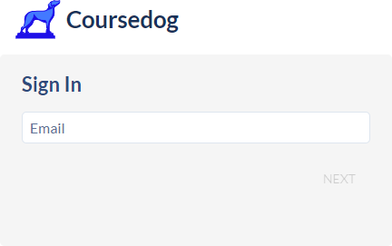
Click NEXT and it should direct you to the USU Coursedog Homepage (if it does not
please reach out to Scheduling at schedule@usu.edu)

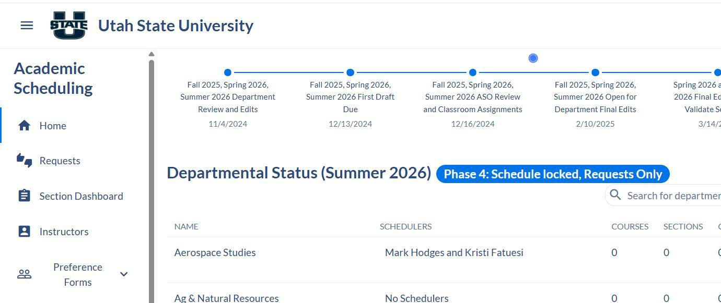

Coursedog Home Screen Overview
When you login, this is the screen you will see:

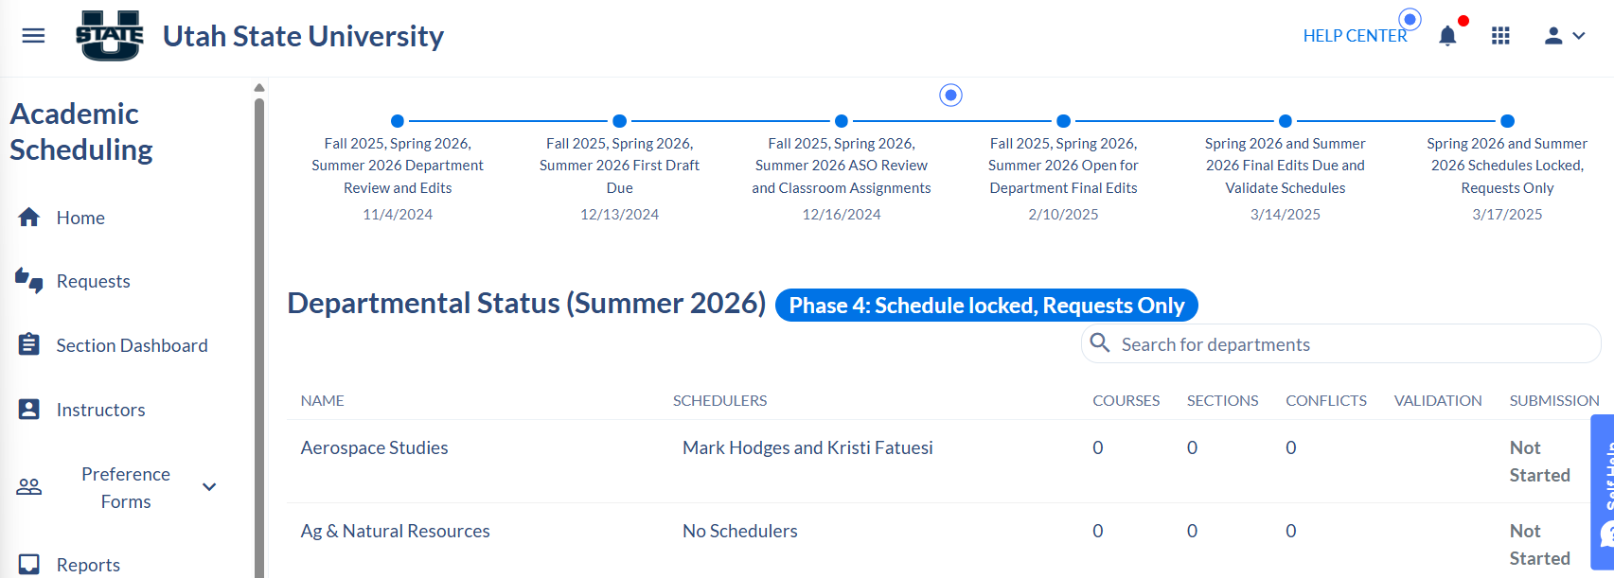

*For Department Heads, you may see more than one tile. If so, click on the Scheduling icon and it will take you to the screen above.

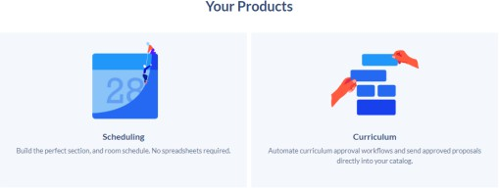
At the top of the page, you will see the timeline for the term.
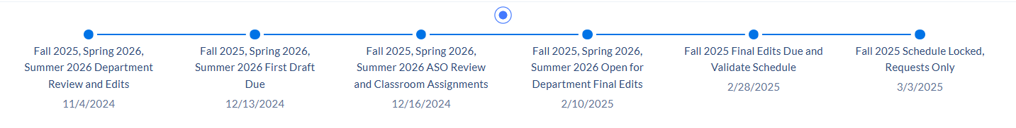
You will also see next to your Departmental Status, which phase we are currently in.

You will see all the department(s)/program(s) that are assigned to you.
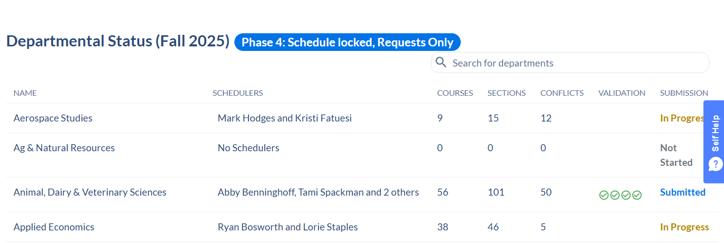
On the left side navigation, there is Home, Requests, Section Dashboard, Instructors, Preference Forms, and Reports

You can always get back to the left side navigation by clicking on the ellipses at the top left corner.



Section Dashboard

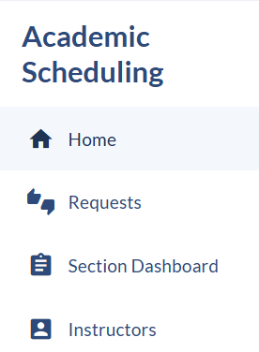
This will take you to the department/program(s) that are set as your primary.

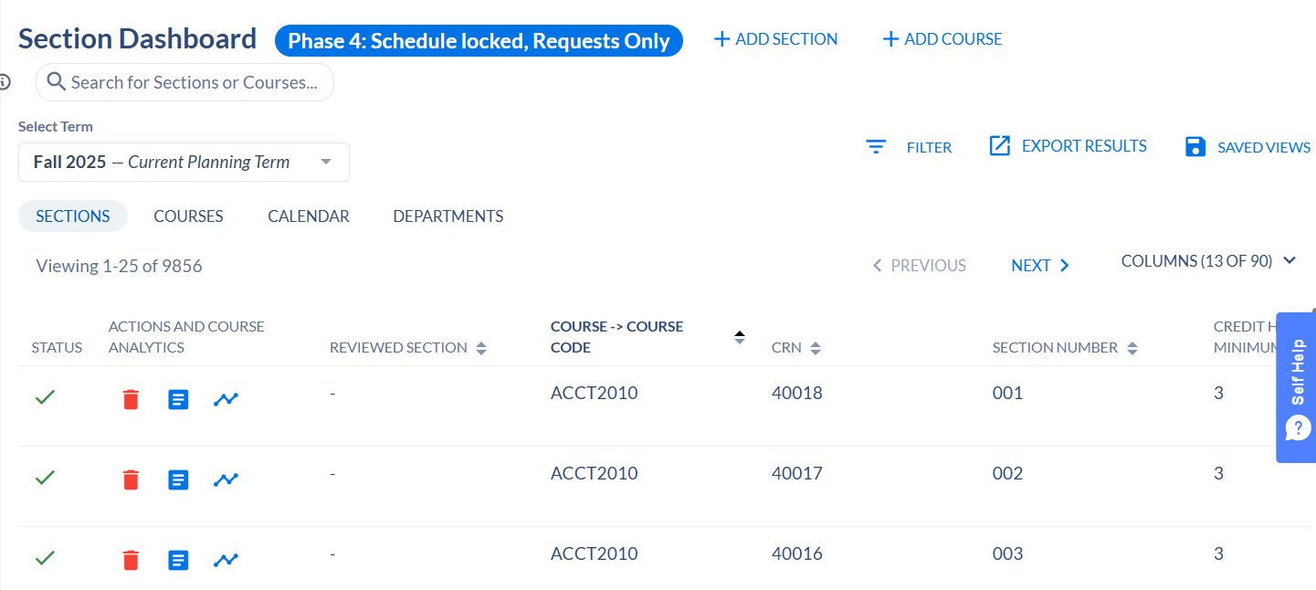

Note: you can go back to the other departments/program assigned to you by clicking on the ellipses.

Click on Home. You will be brought back to the home page.

Terms

You can toggle between terms to view.

Click on the down arrow under “Select term” (e.g. Fall 2025)

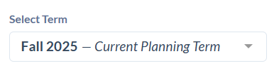

Select the desired term.
*Always be sure you are updating sections in the current planning term.

To set the default term on your dashboard:
- Click the down arrow next to “Profile” in the top right corner of the screen.
- From the dropdown menu, select “Account Settings”
- Look for an option labeled “Terms”
- Choose your preferred term from the list.

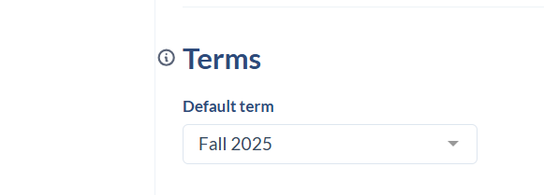

Adding a Course from Inventory
Adding a Course from Inventory means that the Course is available in your department, but you do not have any sections of the course available for the term yet.
You can add a course from course inventory by clicking on the blue “+ Course” button.
A new window populates

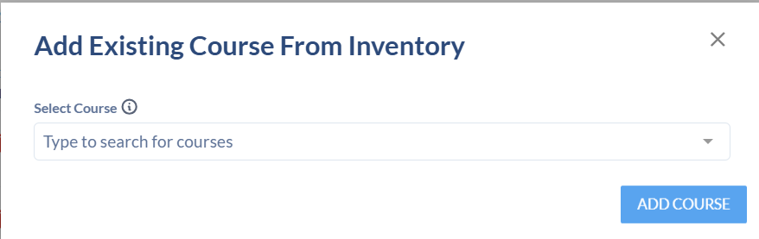

Search for Course by typing the subject in the Select Course field

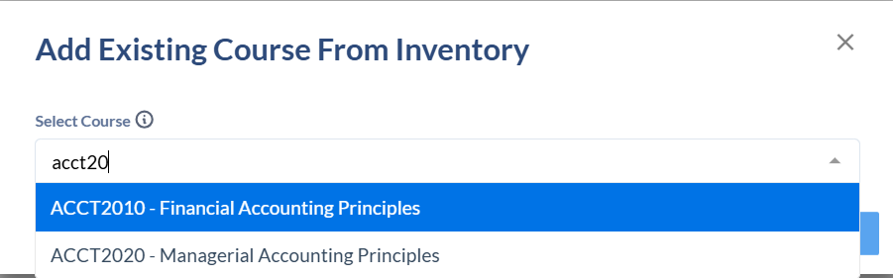
Click on ADD COURSE
The course now shows as an option to add sections.

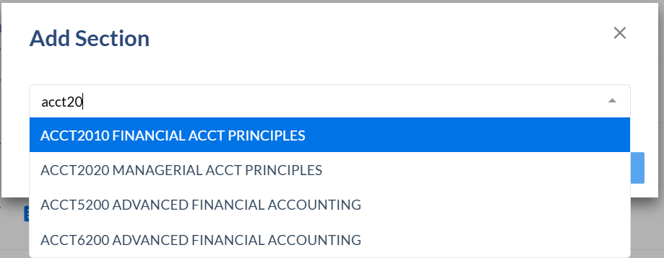

Requests
On the left side navigation, click on Requests
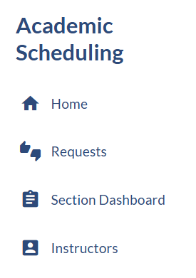

Rooms
Allows you to view the active rooms.

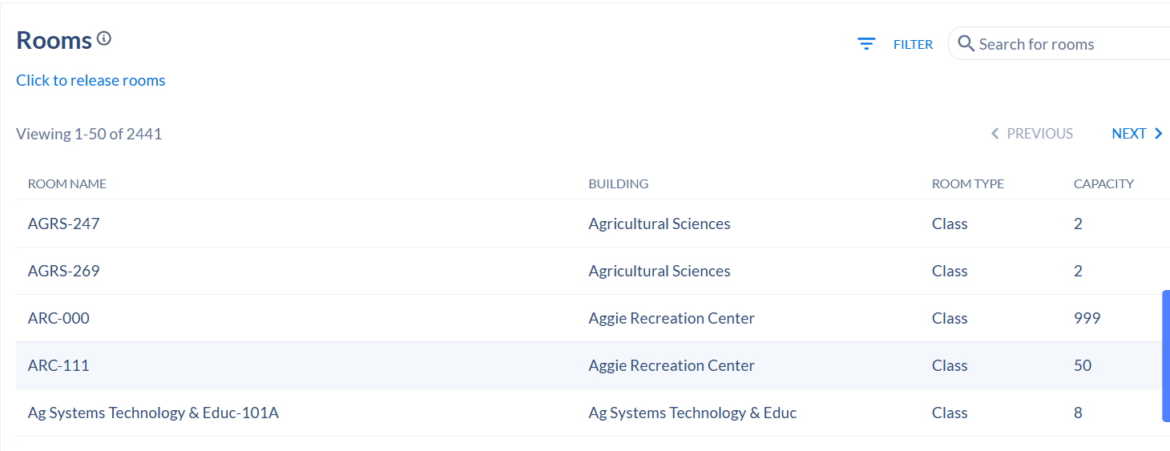

Adding a Section

If the term is not locked, and you need to add an additional section to a term:

To add a new section, click Section Dashboard, and then “+ Add Section”

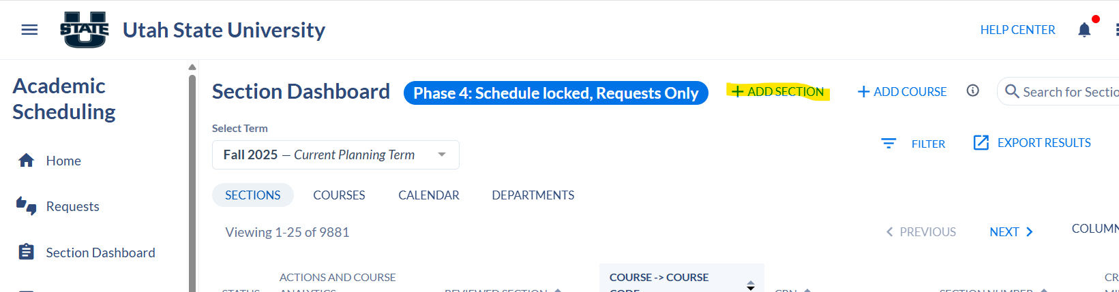

Enter the Subject and Course Number:
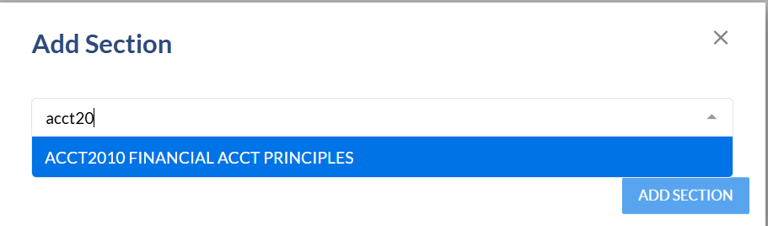

CRN: has not been set. This will be set once Coursedog syncs with Banner.
Section Number: List the section code for this section based on the instructional method. If you are not sure what the section number should, be refer to this website or contact us at schedule@usu.edu:
https://www.usu.edu/registrar/scheduling/section-codes

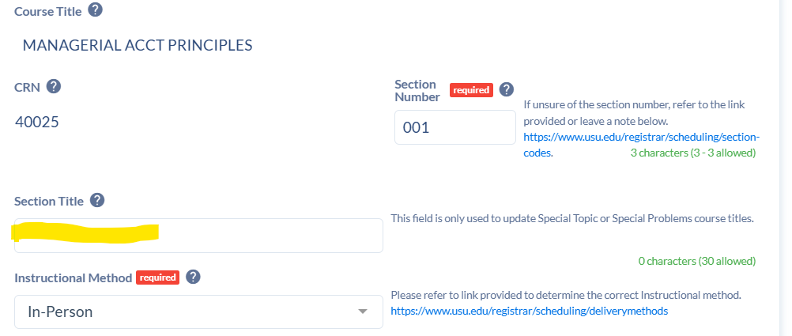
Section Title: If this is a Special Topics or Special Problems course, you can edit the title of the section.

Instructional Method:
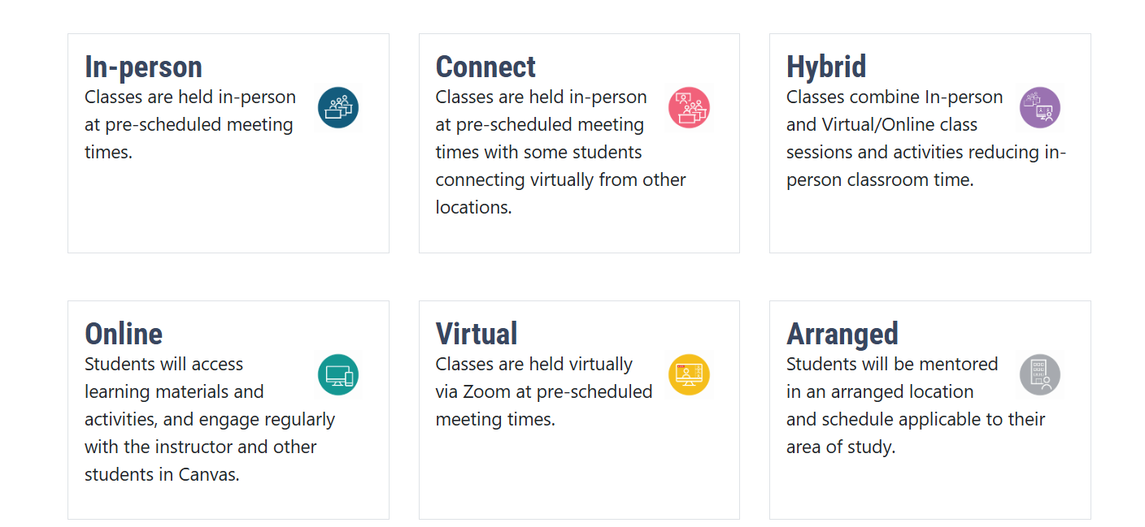

Schedule Type:

Select the appropriate schedule type for this section.
Ex: Lecture, Arranged, Individualized Instruction

Campus: Choose the appropriate campus

Ex: Logan, “Online, Virtual, Arranged”, Statewide Campus

Part of Term: Choose from one of the options below:
Logan General Full Session (1)
Logan First 7-Week Session (A)
Logan Second 7-Week Session (B)

Open Learning - If the section falls outside of the standard parts of term dates, please contact the Scheduling Office and we build the section as “Open Learning” for you. This means that the class is shorter or longer than 7 or 14 week standard terms.

Statewide Program Attributes:
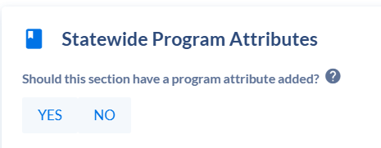
If this section requires a specific program rate, please mark “yes”, and then list which program attribute should be added.

Meeting Patterns & Rooms
Click on the +MEETING PATTERN to select from preset meeting pattern options.

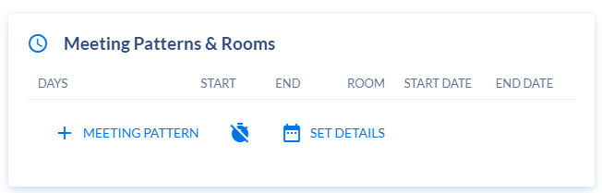

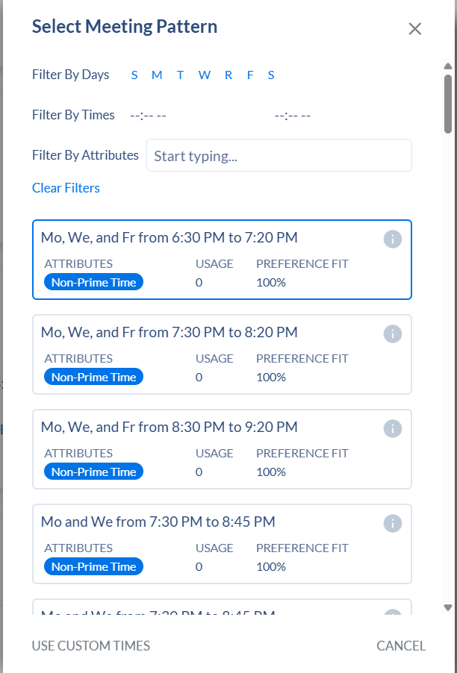

- You can improve search results, by filtering on the following:
  - Filter By Days
  - Filters by Times

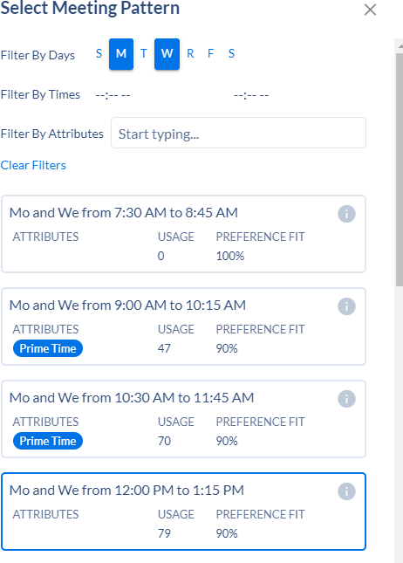
Click on the desired meeting pattern day and time. It will populate the Meeting Patterns and Rooms Field.

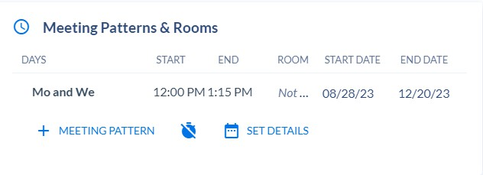
If you want to delete the meeting pattern, hover over the meeting pattern and you will see the greyed circle with the line through it.

Bring your mouse over the greyed circle with the line through it and it will turn red. This will allow you to delete.

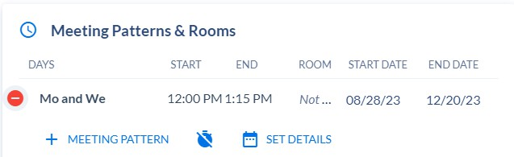

If you need to add a meeting pattern that is not listed, click on “Use Custom Times” at the bottom:

Instructors

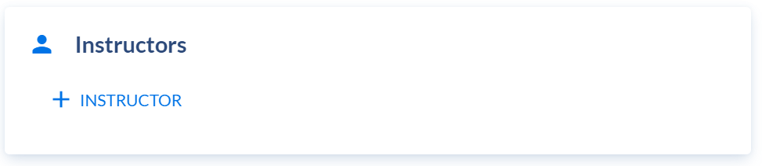
Click on +INSTRUCTOR
A new window will populate with a list of instructors.

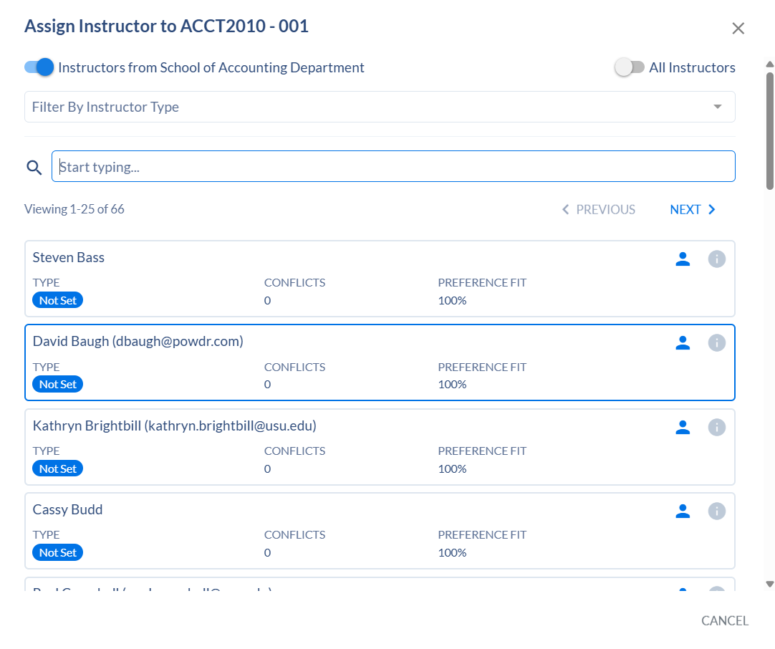

Relationships
Below you may see sections that have been cross-listed or linked with this section under “Relationships”. If you need to adjust, add, or remove a crosslisted or linked section, please specify that under the "Link and Crosslist”

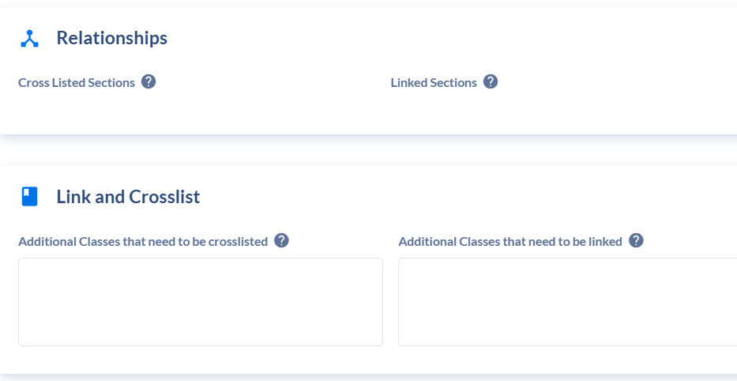

Credit Hours/Units
Only make a change if the course is a variable credit class.

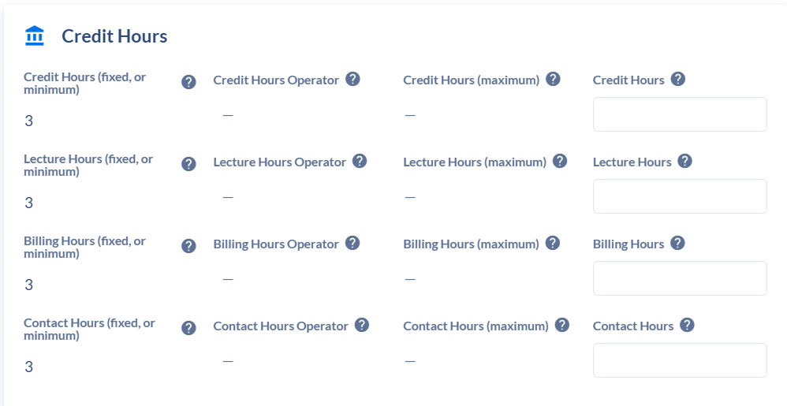

Enrollment Settings
Enter enrollment capacity.
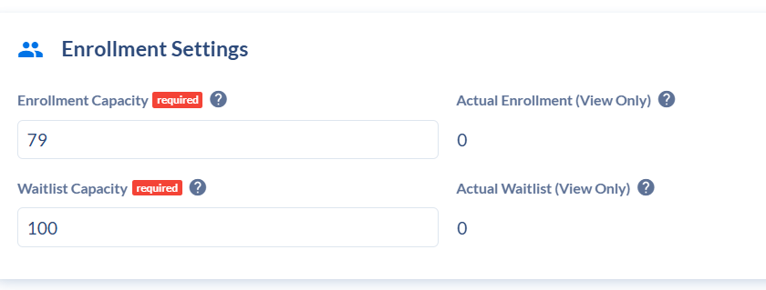

Room Preferences

You can choose to select a “Preferred Building” or “Preferred Building and Room” or leave blank.

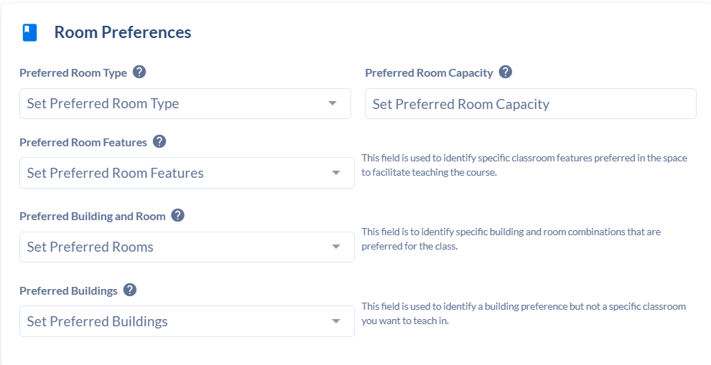

Notes to Academic Scheduling Office
Enter any additional information about the section that the Academic Scheduling office needs to know.

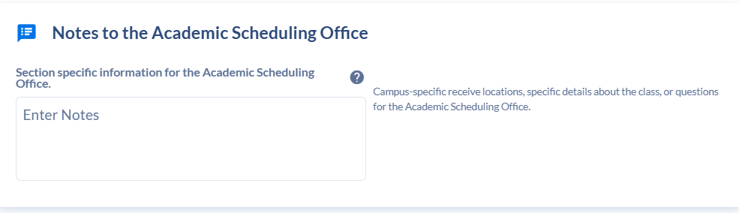

Other Settings
If the course requires Approval, select the appropriate option from the drop-down menu.
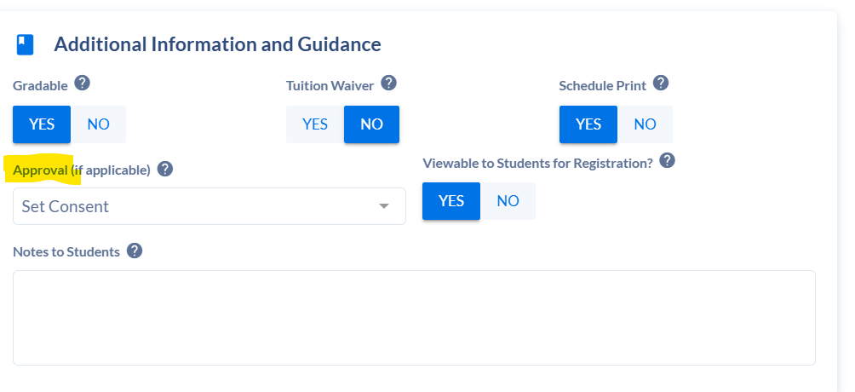
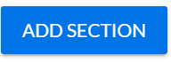
Click ADD SECTION

If at any point you need to exit the Section, click on CANCEL
Choosing PROCEED & CLOSE: this will not save any work that you have done Choosing GO BACK: this will take you back into the Section Editing.
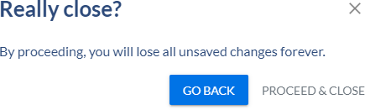

Editing an Existing Section
Under Section Dashboard search for the Section you want to edit.

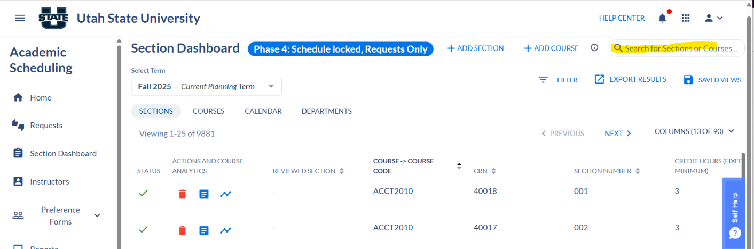

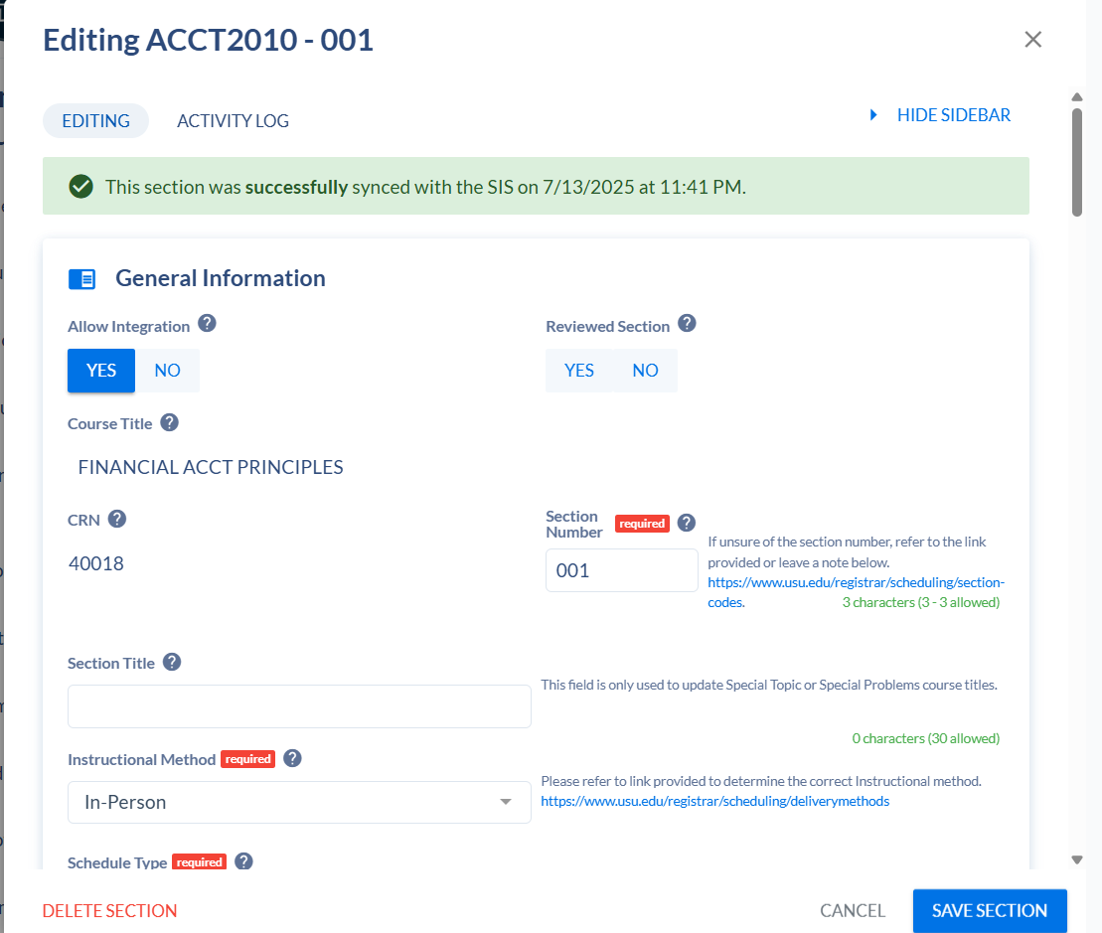
Click on the section to be edited.

Adjustments can be made to:
- Instructional Method
- Part of term
- Campus
- Schedule Type
- Meeting Patterns & Rooms
- Instructors
- Variable Credit Hours
- Enrollment Settings
- Room Preferences
- Approvals
- Notes

Once the desired change has been made, click on SAVE SECTION.

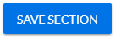

Cancelling a Section
In order to cancel a section that is no longer needed.

Search for the section under Section Dashboard.
Click “YES” under the “Cancellation Requested”
Click on “Save Section”

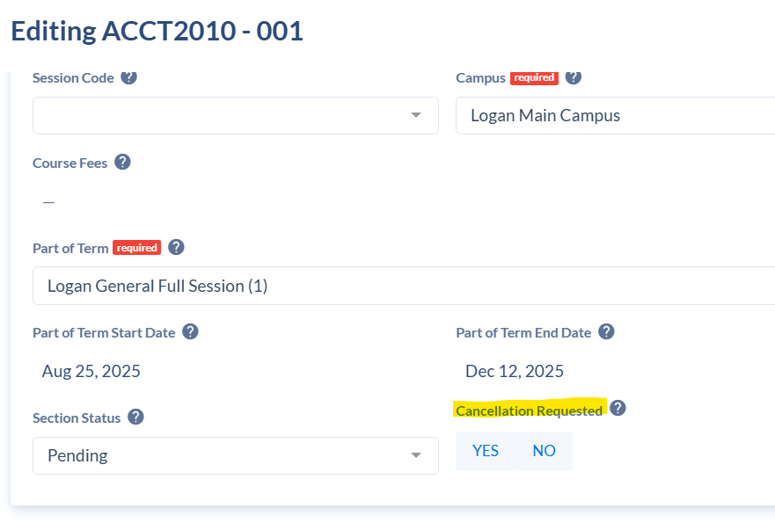

Section with Multiple Instructors

This can be done on new sections or existing sections. Search for the section under the Section Dashboard.
Scroll down to Instructors
Click on +INSTRUCTOR
A new window will populate with a list of instructors. You can search by instructors assigned to your department.

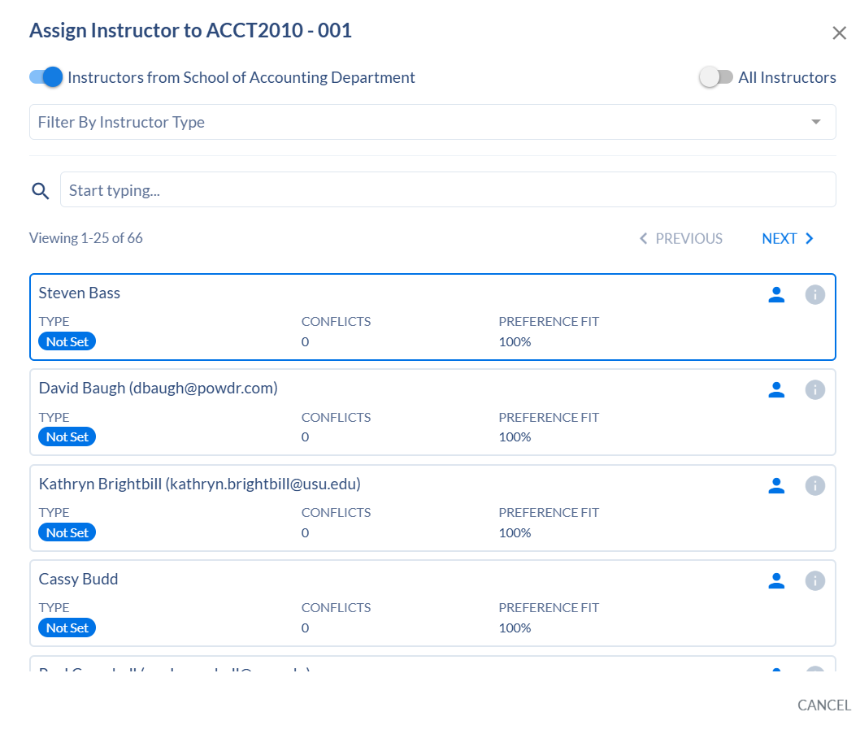

Select the desired instructor

Click on +INSTRUCTOR to add another, repeat this step if needed.

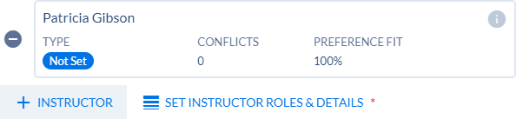

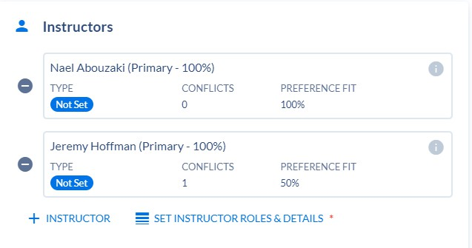
Once all instructors have been added, click on SET INSTRUCTOR ROLES & DETAILS

Click on the instructor’s name in the new window to assign the Primary Instructor Role. Only one instructor can be set as Primary. The other must Non-Primary.

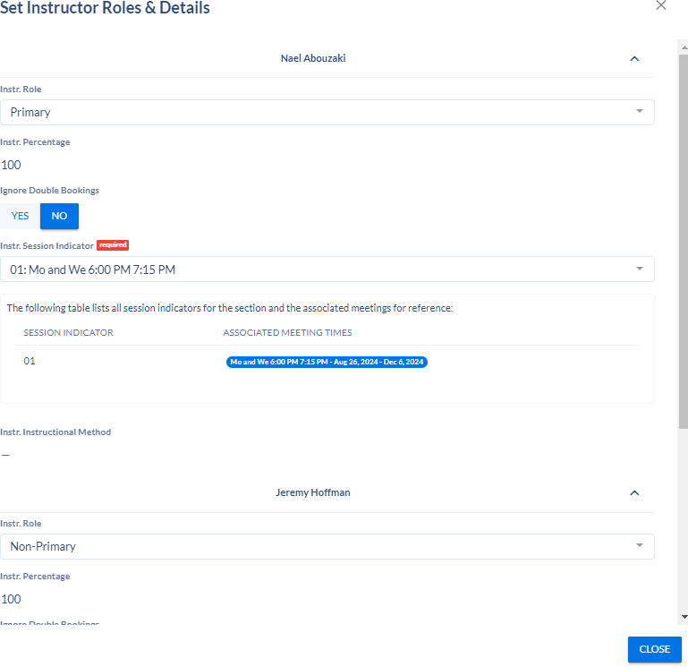
Click CLOSE
*Please note that a meeting pattern must already be in place to successfully save the section and to set the instructor role.

Click SAVE SECTON (if existing section) or ADD SECTION (if adding a new section)

Section with Multiple Meeting Patterns
This can be done on new sections or existing sections.
Search for the section in your Section Dashboard.
Meeting Patterns & Rooms
Click on the +MEETING PATTERN to select from preset meeting pattern options.

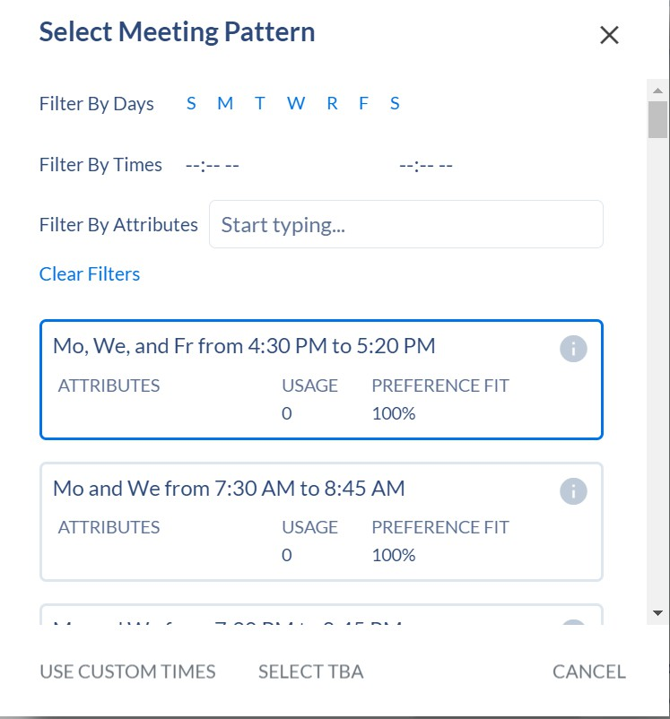
- You can improve search results, by filtering on the following:
  - Filter By Days
  - Filters by Times

Click on the desired meeting pattern day and time.

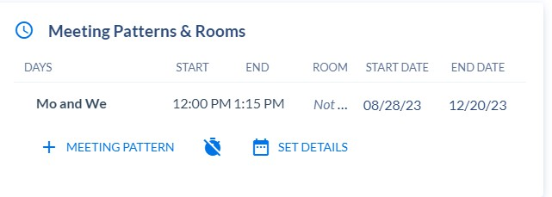

Click on the +MEETING PATTERN again to add additional times.

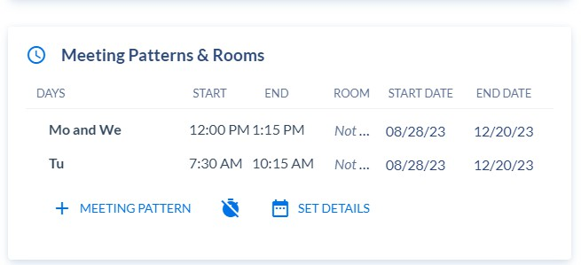

Repeat if needed. Once all meetings days and times have been selected click on Save Section.

Adding a New Section if the Term is Locked
Click on Request on the left side navigation page

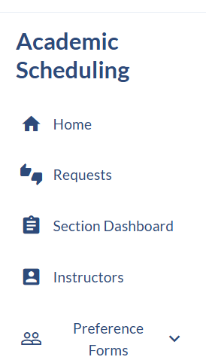

Click on +CREATE REQUEST (at top of page)

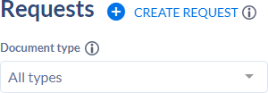
A new window will populate
Select option by clicking on the drop down arrow

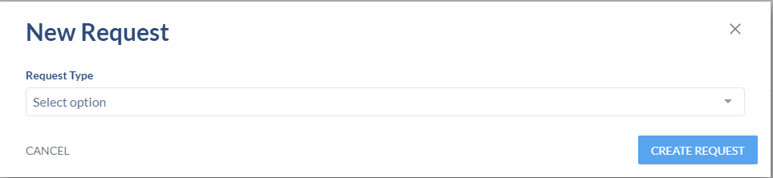

Choose Section Change and click CREATE REQUEST

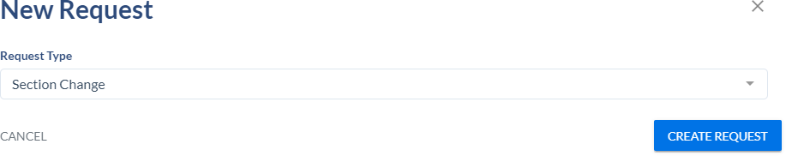

This will open a new window
Click on the drop-down arrow in the Type of Change field

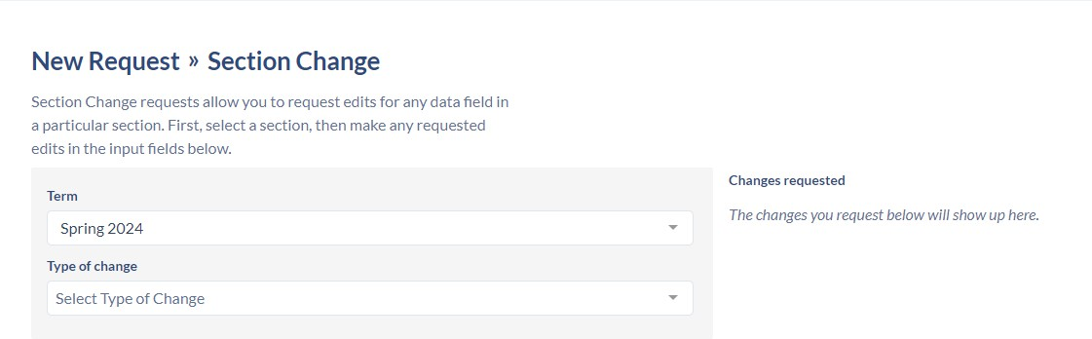
Select Add Section

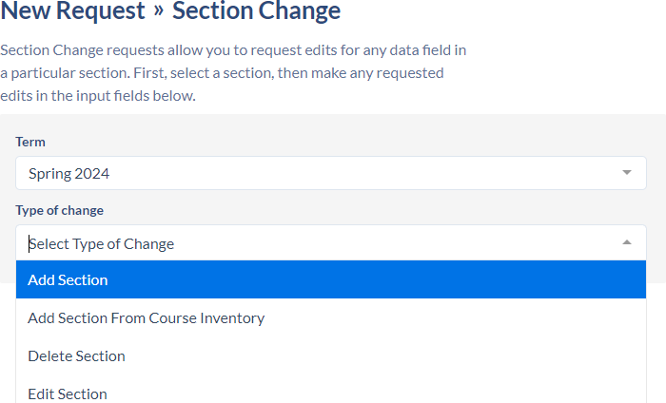

Select a course (begin typing in the search field)

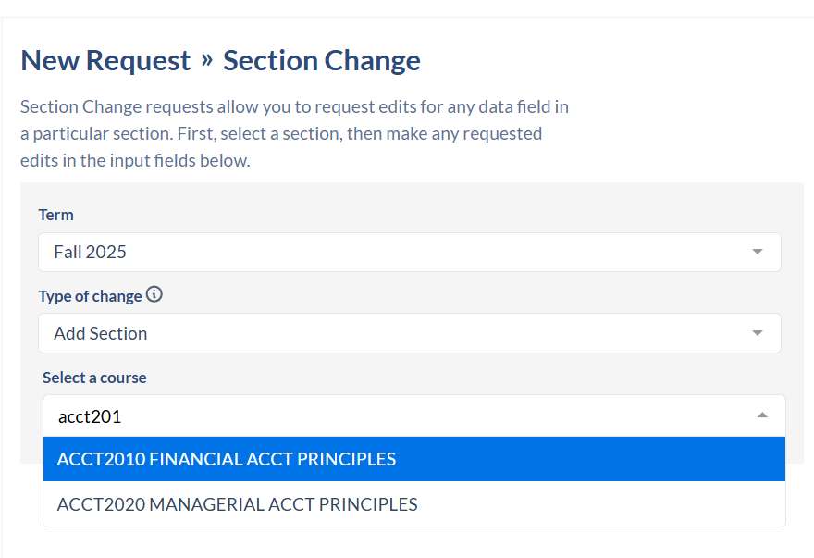
Enter a reason for the request.

**DO NOT CLICK SUBMIT REQUEST YET**
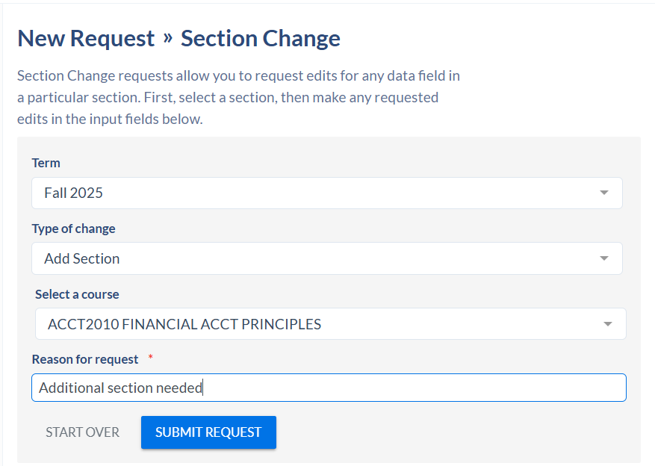

Complete the rest of the section information as if you were adding a new section.
Once complete, now you can click on SUBMIT REQUEST at the top of the page.
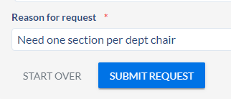

The request will go to your Department Head for approval and then to the Scheduling Office to be processed.
You can review the status of your request
Click on Requests on the left side navigation
Click on Created By Me

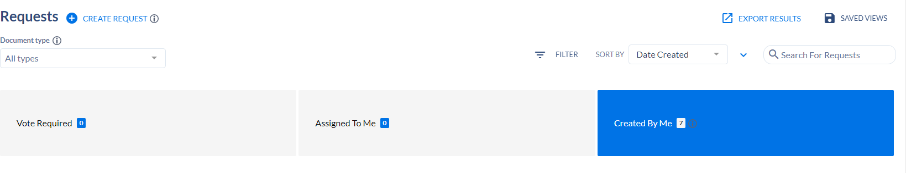
You will see all of your initiated requests and status. Once the request is approved, the section will update in Coursedog.

Adding a Section from Course Inventory
If there are no other sections of this course available for the term you will need to add the course from inventory.
Click on Request on the left side navigation page

Click on +CREATE REQUEST (at top of page)

A new window will populate
Select option by clicking on the drop down arrow

Choose Section Change and click CREATE REQUEST

This will open a new window
Click on the drop-down arrow in the Type of Change field
Select Add Section from Course Inventory

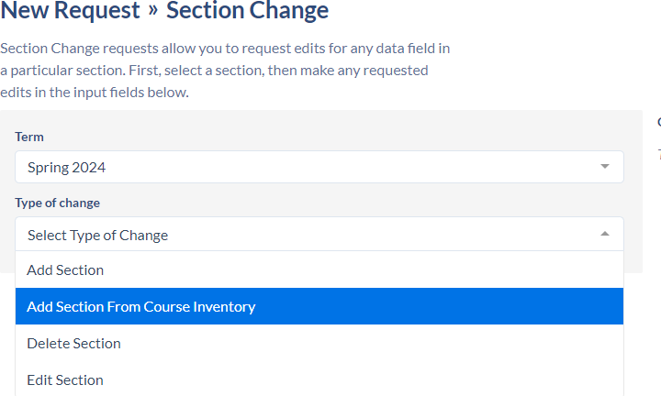

Select a course (begin typing in the search field)

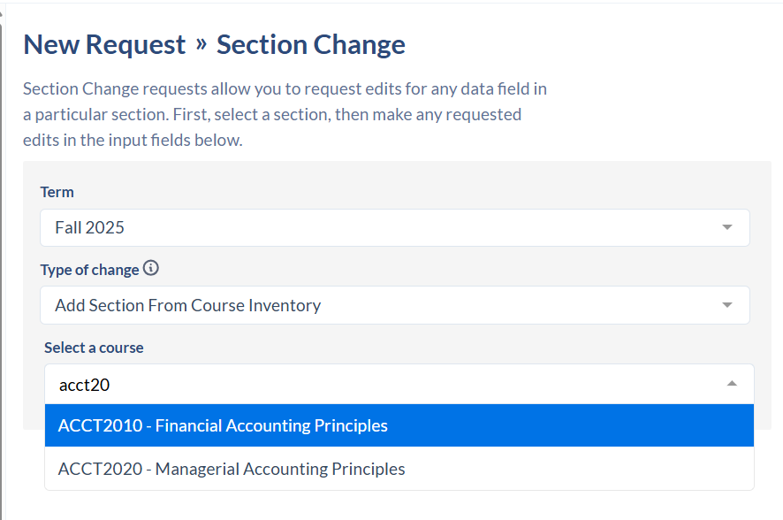

If a section of this course already exists for the term, there will be a warning message. STOP. Choose Start Over or reselect the appropriate course. (If a section already exists you need to “Add a Section” instead of “Add a Section from Course Inventory”.

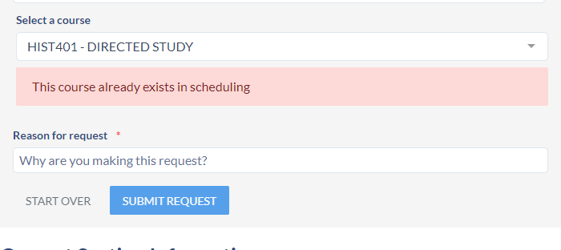

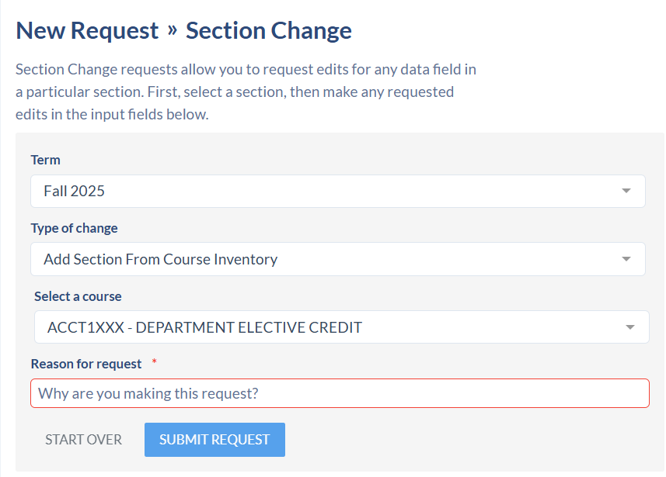
Enter a reason for the request.

**DO NOT CLICK SUBMIT REQUEST YET**

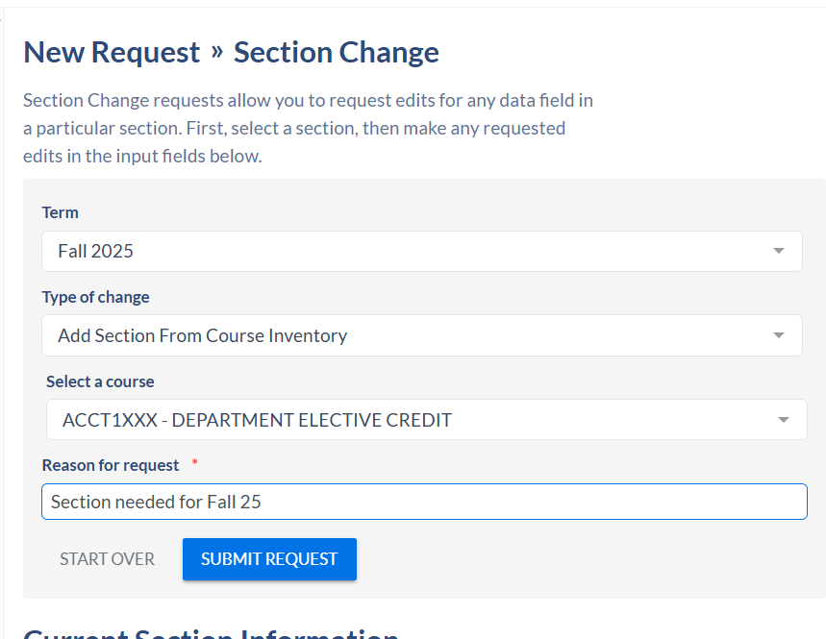

Complete rest of the section information as if you were adding a new section.
Once complete, now you can click on SUBMIT REQUEST at the top of the page.

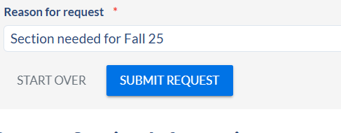

The request will go to your Department Head for approval and then to the Scheduling office to be processed.
You can review the status of your request
Click on Requests on the left side navigation
Click on Created By Me

You will see all of your initiated requests and status.
Once the request is approved, the section will update in Coursedog.

