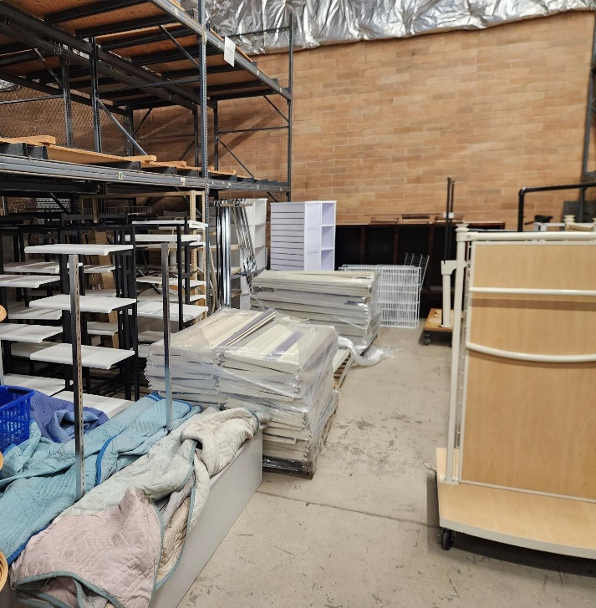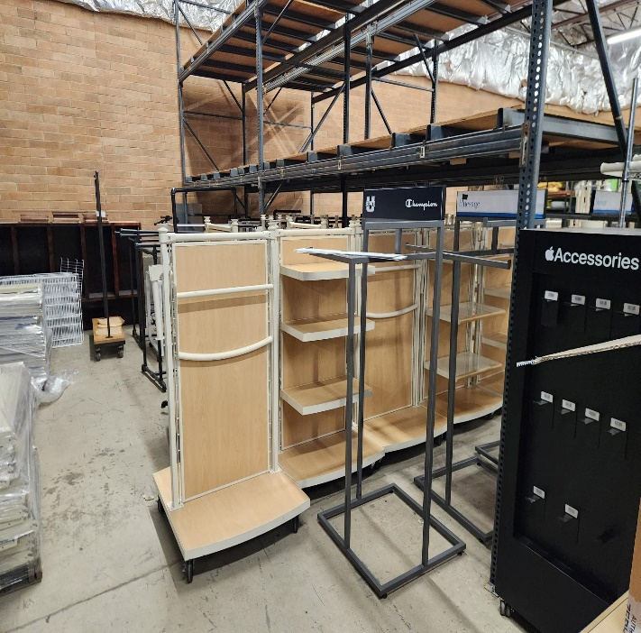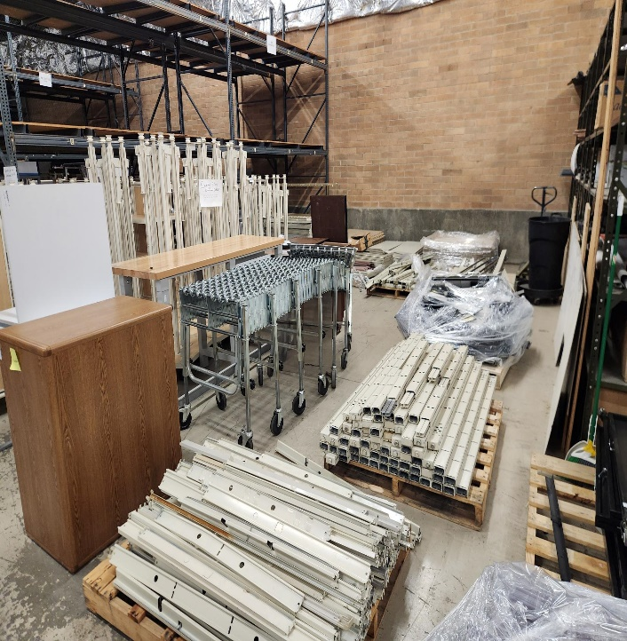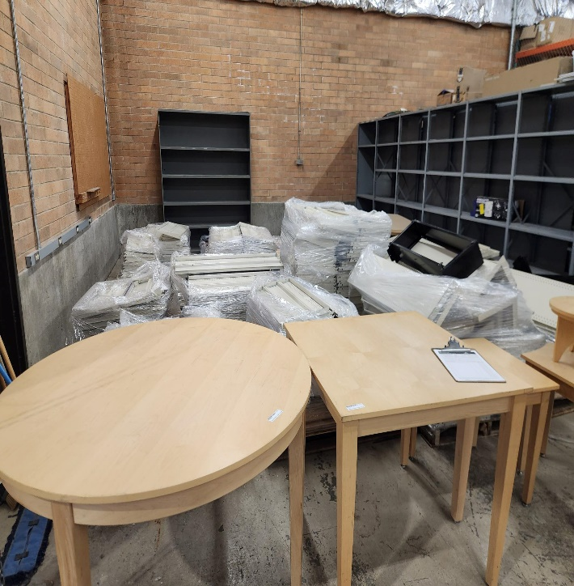
LOT OF RETAIL STORE DISPLAY ITEMS – ASK TO SEE
- SHELVING
- TABLES
- GONDOLAS
- & MORE
VARIOUS PRICES AVAILABLE 08/27/2026

