WESTERN MVP
SNOWPLOW
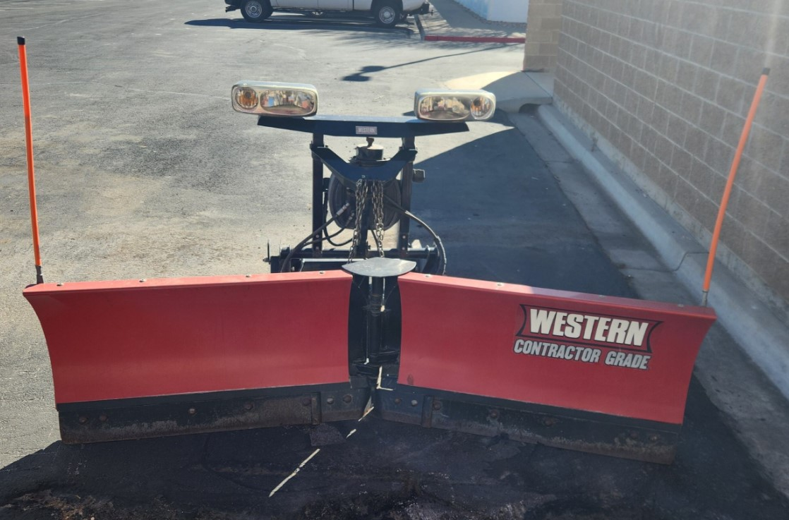
- LOCATED AT THE ROOSEVELT CAMPUS – NO DELIVERY, Must Pick-Up
- 8 ½” “V’ WITH LIGHTS
- INVENTORY NUMBER 157536 - AVAILIABLE 04/28//2026
$4500.⁰⁰

